

UNITED VOICES FOR GLOBAL IMPACT (UVGI)
P.O. Box 776, Zomba, MALAWI
Phone: +265 999 23 75 60 Email: brown.masingati@gmail.com

REPORT ON BUSINESS MANAGEMENT AND FINANCIAL LITERACY TRAINING AND ALSO ON HEALTH AND HYGIENGE FOR CBCCs

TO : Dr. Hala Ghoson (UVGI Director) and the UVGI
Board Directors.

FROM : UVGI (Malawi) Ambassadors.

DATE OF REPORTING : 18th December, 2025

ACTIVITY DATE(S) : 4th and 5th December, 2025

ACTIVITY VENUE : Mtima Village Headquarters

TOTAL AMOUNT SPENT : US$152

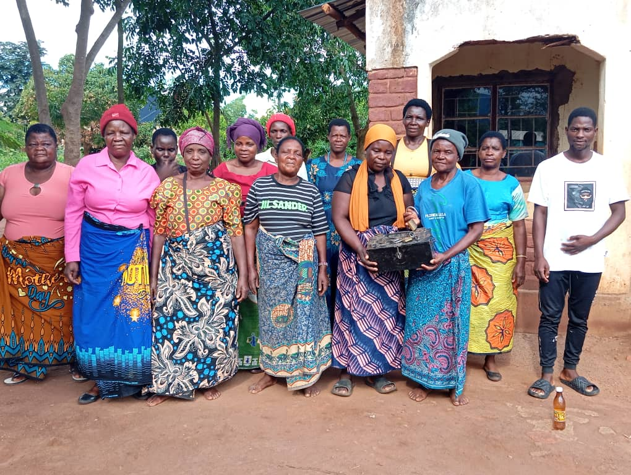
Some of the women in the training posing for a group photo with a youth club chairperson

INTRODUCTION

At least twenty women from Ntima and Nkalapa villages were all smiles on Thursday, 4th December 2025 afternoon after undergoing a 1-day training in Business Management and Financial Literacy. The women’s joy exceeded on Friday the 5th of this month when they attended a 1-day training in Health and Hygiene for Tiyamike and Mwayiwathu CBCCs. These trainings were organized by the United Voices for Global Impact (UVGI) Malawi with support from the UVGI (USA).

1. BUSINESS MANAGEMENT AND FINANCIAL LITERACY TRAINING

TRAINING/ACTIVITY OBJECTIVES
The Business Management and Financial Literacy Training had each its own objectives which are outlined below:

A. Objectives of the business management training

- Effective Resource Utilization: Ensuring the optimal use of all resources (human, financial, material, and technological) to maximize efficiency and productivity.
- Goal Achievement: Directing group efforts toward the accomplishment of predetermined organizational goals and objectives.
- Skill Development: Fostering the development of essential skills such as planning, organization, direction, control, decision-making, and problem-solving.
- Adaptability to Change: Helping managers and businesses adapt to a rapidly changing business environment, including technological changes and market shifts.
- Sustainable Growth: Developing strategies for generating new businesses, increasing the value of existing companies, and ensuring long-term success and sustainability.

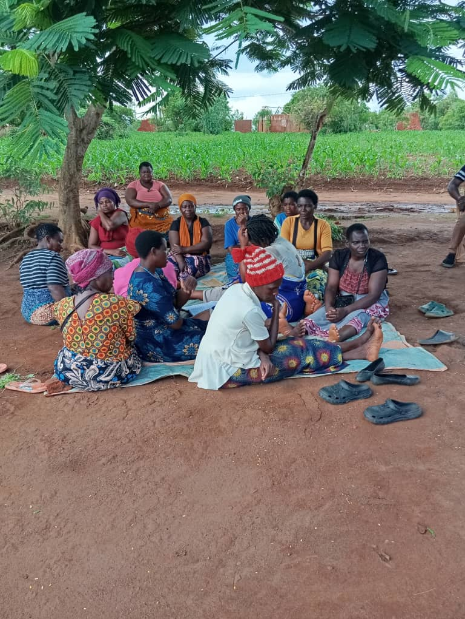
The women listening attentively to the training facilitator
B. Key objectives of the Financial Literacy training:

- Developing Budgeting Skills: Learning to track income and expenses, create a realistic budget, distinguish between needs and wants, and prioritize spending to live within one's means.
- Cultivating Saving Habits: Emphasizing the importance of regular saving, building an emergency fund (typically 3-6 months' worth of expenses), and setting achievable short and long-term financial goals.
- Promoting Responsible Credit and Debt Management: Understanding how credit works, the impact of interest rates and compound interest, maintaining a healthy credit score, managing existing debt efficiently, and avoiding predatory lending schemes.
- Introducing Investment Principles: Providing basic knowledge of investment vehicles like stocks, bonds, mutual funds, and retirement accounts (e.g., 401(k)s, IRAs), while also explaining key concepts such as risk and return, diversification, and the impact of inflation.
- Enhancing Decision-Making and Planning: Empowering individuals to evaluate financial products, assess risks, plan for major life events (education, homeownership, retirement), and protect assets through appropriate insurance.
- Fostering Financial Responsibility: Instilling a mindset of continuous learning, adapting to changing economic conditions, and making ethical financial choices that contribute positively to personal and community well-being.

TRAINING FACILITATORS
The activity was co-facilitated by two Government officers from the departments of Trade and Community Development, respectively at Zomba District Council. The facilitators were/are individuals with good knowledge and expertise in business and financial management and have been conducting such trainings in various parts of Zomba district and some other parts of Malawi.

TRAINING MODULE/TOPICS
The women have been trained in selected topics/areas considering the fact that the training was just for only 1 day.
In Financial Literacy, these were the topics:
- Budgeting and Money Management
- Saving
- Debt and Credit Management

In Business Management, these were the topics:
- Fundamentals
- Finance & Accounting
- Marketing & Operations

Key Skills Developed
The training has enabled the participants/women to develop the following skills:
- Analytical Thinking & Problem-Solving
- Decision-Making & Rational Choices
- Communication & Interpersonal Skills
- Innovation & Creativity
- Application of Theoretical Models to Real Scenarios

IMPACT AND BENEFITS OF THE TRAINING

Impact of the Business Management Training for the Small and Medium Enterprises:
- Building Foundational Business Skills: Business management training equips small business owners with foundational skills essential for success in today’s competitive market landscape. These skills encompass a broad spectrum of areas, including financial management, strategic planning, marketing, human resources, and operations management.
- Fostering Leadership and Management Excellence: Effective leadership and management are crucial for driving growth and inspiring high performance within small businesses. Business management training programs focus on developing the leadership and management capabilities of entrepreneurs, empowering them to lead with confidence, vision, and resilience.
- Improving Operational Efficiency and Effectiveness: Streamlining operations and improving efficiency are key priorities for small businesses seeking to optimize their resources and maximize profitability. Business management training provides small business owners with strategies and best practices to enhance operational efficiency and effectiveness across all aspects of their operations.
- Navigating Growth Opportunities and Challenges: As small businesses grow and expand, they face a myriad of opportunities and challenges along the way. Business management training equips entrepreneurs with the knowledge, skills, and strategies needed to navigate the complexities of growth and scale their ventures successfully.

Impact of the Financial Literacy Training for the Small and Medium Enterprises:
- Improved Money Management: Participants are/were better equipped to create and stick to budgets, manage day-to-day expenses, and control cash flow.
- Increased Savings and Investment: Training boosts self-reported savings rates and encourages the use of formal financial institutions (like banks and cooperatives) rather than informal methods. It also helps people plan and save for long-term goals like education and retirement.
- Enhanced Well-being: By fostering confidence and providing the tools for financial security, financial literacy will contribute to an overall better quality of life and personal well-being.
- Better Financial Decision-Making: SME owners with higher financial literacy are better at evaluating investment opportunities, managing debt, and controlling costs.
- Improved Access to Finance: Enhanced financial record-keeping and a better understanding of creditworthiness and loan conditions help businesses secure funding and negotiate more favorable financing terms.
- Increased Resilience and Sustainability: Financially educated entrepreneurs are more likely to develop business plans, use risk management strategies (like financial forecasting), and reinvest revenues efficiently, leading to greater business success and the ability to withstand economic shocks.

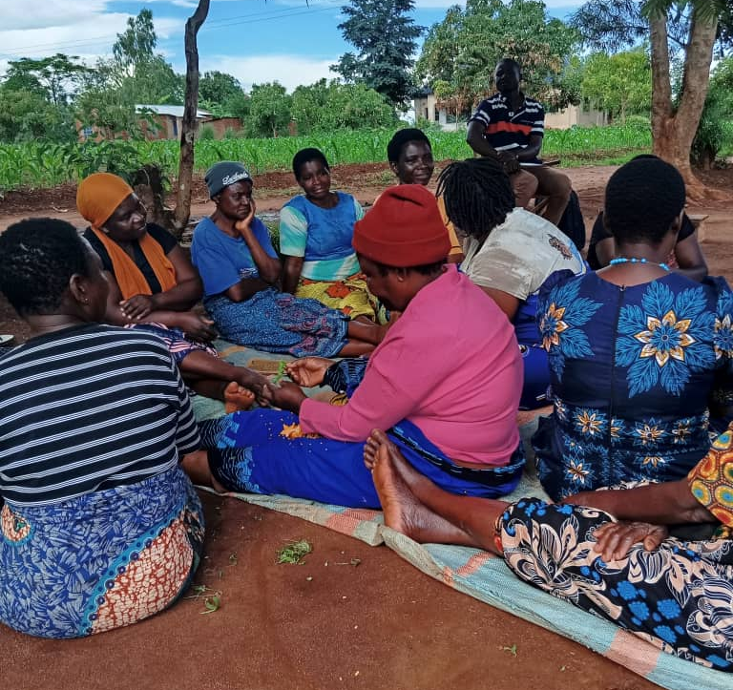
The women in a group discussion as Brown Masingati is keenly following their discussion

SUCCESSES OF THE TRAINING
The business management and financial literacy training has had several successes but the most notable ones are as follows:

Acquisition of Multiple Business Skills: The women of Ntima village have acquired multiple skills that will help them build up their businesses, such as analytical thinking and problem-solving skills, decision-making skills, communication and interpersonal skills.
Cultivating Saving Habits: The participants have been empowered on regular saving, with the aim of building an emergency fund for future goals and unexpected events.
Budgeting and Money Management: The foundation of financial literacy involves understanding where your money goes.
Investing and Retirement Planning: This area focuses on growing wealth over time.
Equipping individuals with leadership knowledge and skills: The leadership knowledge and skills are necessary for the participants to effectively lead and operate small scale businesses.

2. HEALTH AND HYGIENE TRAINING FOR TIYAMIKE AND MWAYIWATHU
CBCCs

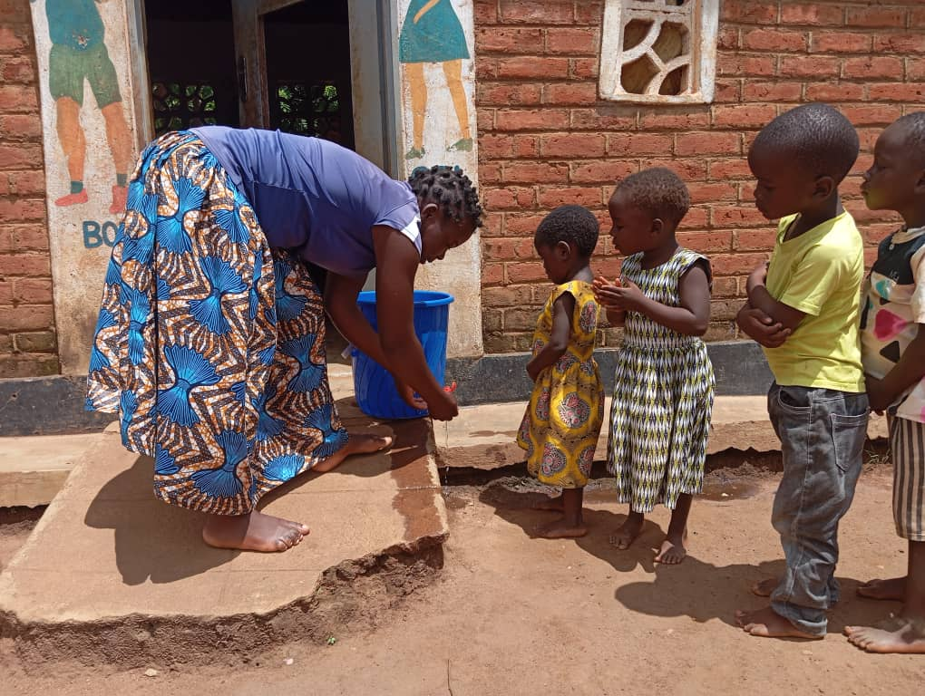
A caregiver at Tiyamike CBCC demonstrating the handwashing hygiene practice to the children
Now on 5th December 2025, ten (10) women from Ntima village representing Tiyamike CBCC, and ten (10) other women from Nkalapa village representing Mwayiwathu CBCC, had the opportunity to undergo a one-day orientation on Health and Hygiene for children centres. This activity was facilitated by the Community Nurse for the area Joyce Mussa.

Primary Objectives of this Orientation
- Preventing illness: To reduce the spread of infectious diseases and promote a healthy environment.
- Promote good hygiene habit: Empower the women to teach their children essential hygiene practices, such as handwashing, covering their mouths when coughing and proper toileting.
- Ensure safety: Creating a safe environment by maintaining cleanliness, sanitation, and proper food handling.

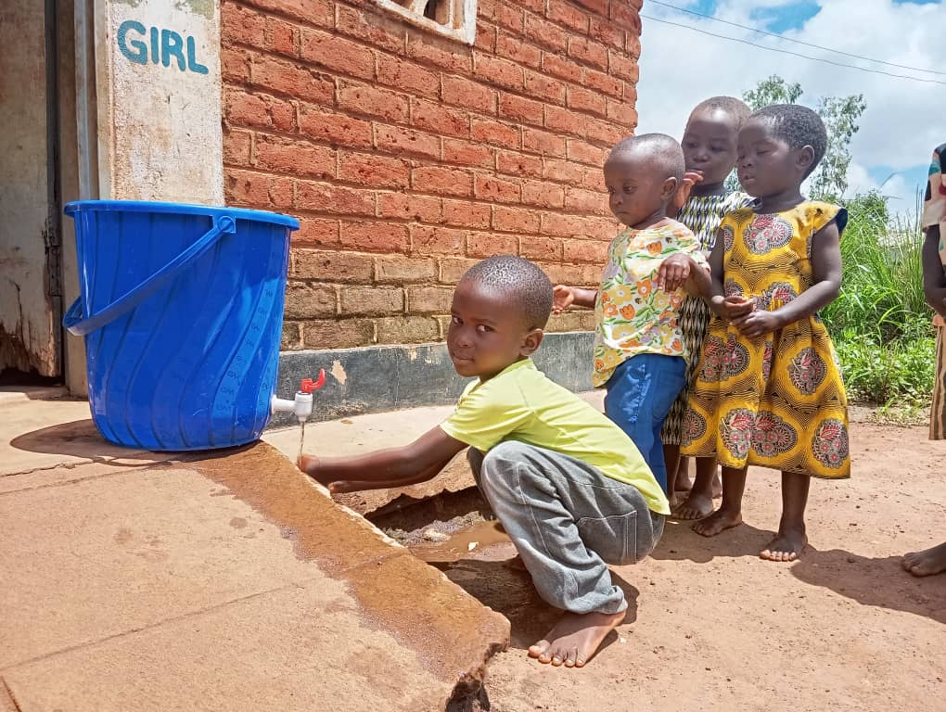
Time to practise proper handwashing: The children practising one after another

Key Focus Areas of the Training/Orientation
- Hand Hygiene: Emphasizing on proper handwashing techniques, frequency, and its importance.
- Infection Control: Empowering the women to Teaching children how to cover their mouths when coughing, dispose of tissues properly, and avoid touching their eyes, noise, and mouths.
- Personal Hygiene: Encouraging child regular bathing, wearing clean clothes, and maintaining oral hygiene.
- Environmental Hygiene: Promote cleaning and disinfecting surfaces, toys, and all other materials regularly.
- Food Safety: Teach the women proper food handling, preparation, and storage practices.

Impact/Benefits of the Health and Hygiene Training/Orientation
- Number of participants: Twenty (20) women representing both CBCCs (of Tiyamike and Mwayiwathu) participated in the training. This indicates that the women were/are so committed to providing health care services to the children in the CBCCs.
- Reduced absenteeism at both CBCCs: Improved hand hygiene practices will very likely lead to low absenteeism rate of the children in the centres.
- Improved health: Proper hygiene habits will very likely reduce the spread of infectious diseases among the children.
- Increased knowledge: Once the women/mothers who have been trained pass on the health and hygiene messages to the children, they (the children themselves) will gain essential knowledge about germ transmission and prevention.
- Better academic performance: Reduced absenteeism and improved health will definitely contribute to better academic outcomes.

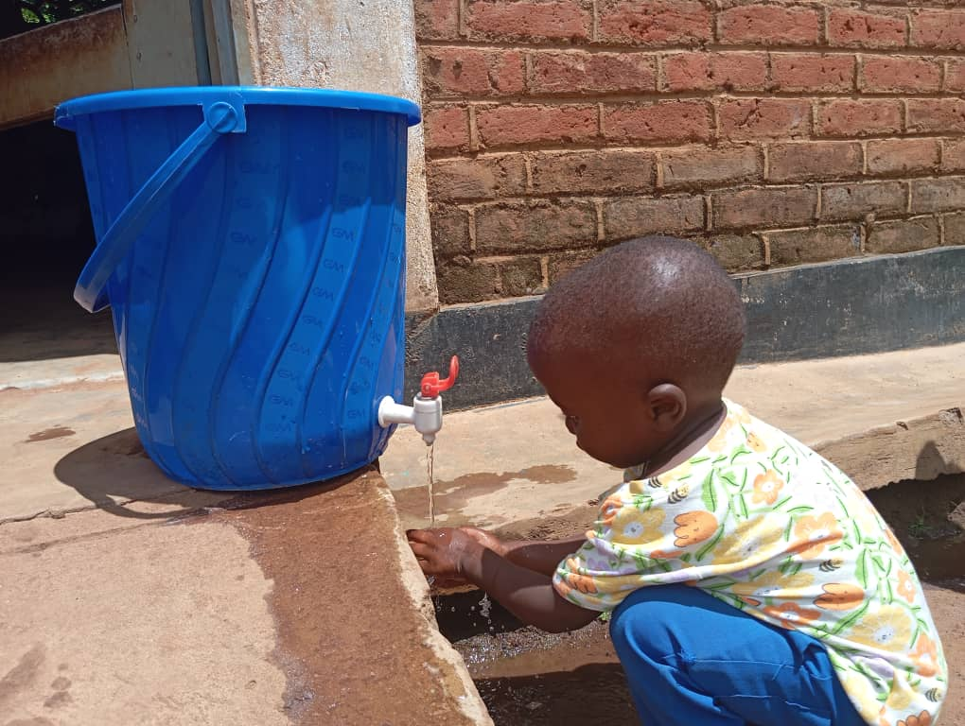
“Now it’s my turn”, This child seems to be saying so while doing the handwashing before his peers

CHALLENGES
- Both trainings, the Business Management and Financial Literacy Training and the Health and Hygiene Training had limited duration to cover all topics for each course.
- Inadequate resources for the trainings.

RECOMMENDATIONS
- The Business Management and Financial Literacy training normally requires a minimum of ten days and at least three day for the Health and Hygiene training, for all the stuff to be tackled/covered. So, in this case there is need for further trainings, probably twice a year until the women are well equipped for their business endeavours.
- On inadequate resources, there is need to consider increasing the resources so they can reach out to all the required areas.

CONCLUSION
Both trainings have so undoubtedly achieved their intended objectives and the impact of each of the trainings is quite great as seen in the report. The participants were very grateful to the UVGI (USA) for the support provided towards these important trainings. Even in her speech, Village Headwoman Ntima (the host of the trainings) assured us (the organizers) that she would make sure that this cordial relationship between her subjects and the UVGI continues to grow from strength to strength for the betterment of her people.

And as UVGI (Malawi) team, we are highly thankful to the Board of Directors and the entire UVGI Management in the USA for all the support towards, not only these trainings, but all other interventions we are implementing in Zomba rural, specifically in Traditional Authority Nkagula. We hope the impact will certainly be that the lives of the target beneficiaries and the entire Nkagula community change completely both in the short-term and in the long-term. On expenditure, we are very proud to report that we spent US$104 for the Business Management and Financial Literacy Training, and US$48 for the Health and Hygiene Training as budgeted, giving a total of US$152. Thanks.

END OF REPORT

