

UNITED VOICES FOR GLOBAL IMPACT (UVGI)
P.O. Box 776, Zomba, MALAWI
Phone: +265 999 23 75 60 Email: brown.masingati@gmail.com

REPORT ON BUSINESS MANAGEMENT AND FINANCIAL LITERACY TRAINING AND ALSO ON HEALTH AND HYGIENGE FOR CBCCs

TO : Dr. Hala Ghoson (UVGI Director) and the UVGI
Board Directors.

FROM : UVGI (Malawi) Ambassadors.

DATE OF REPORTING : 18th December, 2025

ACTIVITY DATE(S) : 4th and 5th December, 2025

ACTIVITY VENUE : Mtima Village Headquarters

2. HEALTH AND HYGIENE TRAINING FOR TIYAMIKE AND MWAYIWATHU
CBCCs

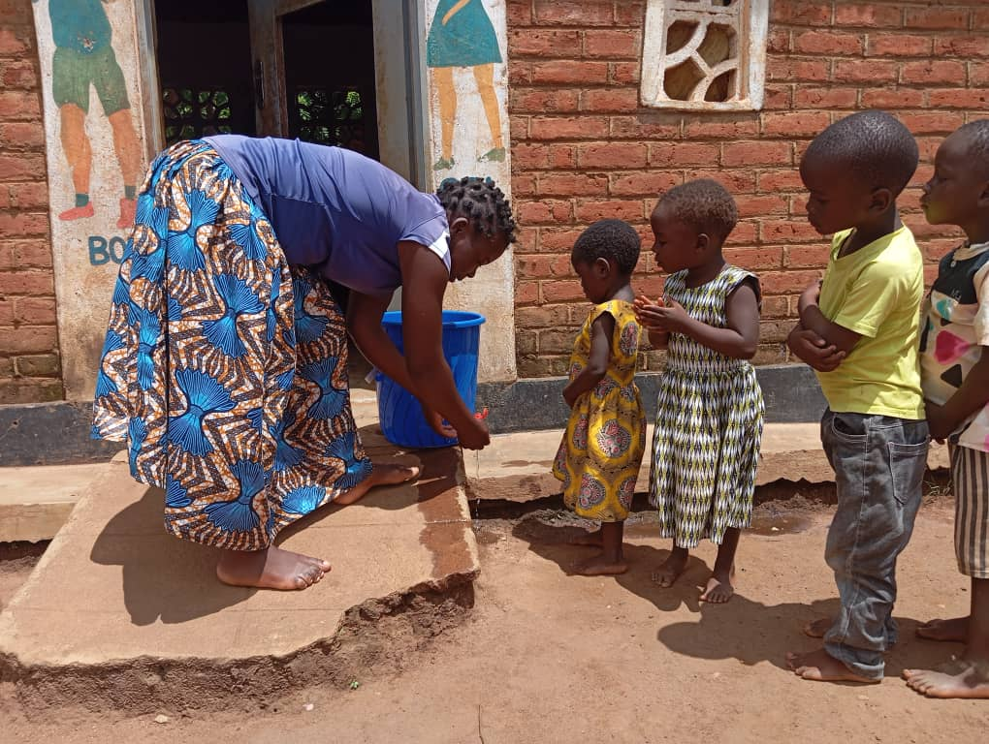
A caregiver at Tiyamike CBCC demonstrating the handwashing hygiene practice to the children
Now on 5th December 2025, ten (10) women from Ntima village representing Tiyamike CBCC, and ten (10) other women from Nkalapa village representing Mwayiwathu CBCC, had the opportunity to undergo a one-day orientation on Health and Hygiene for children centres. This activity was facilitated by the Community Nurse for the area Joyce Mussa.

Primary Objectives of this Orientation
- Preventing illness: To reduce the spread of infectious diseases and promote a healthy environment.
- Promote good hygiene habit: Empower the women to teach their children essential hygiene practices, such as handwashing, covering their mouths when coughing and proper toileting.
- Ensure safety: Creating a safe environment by maintaining cleanliness, sanitation, and proper food handling.

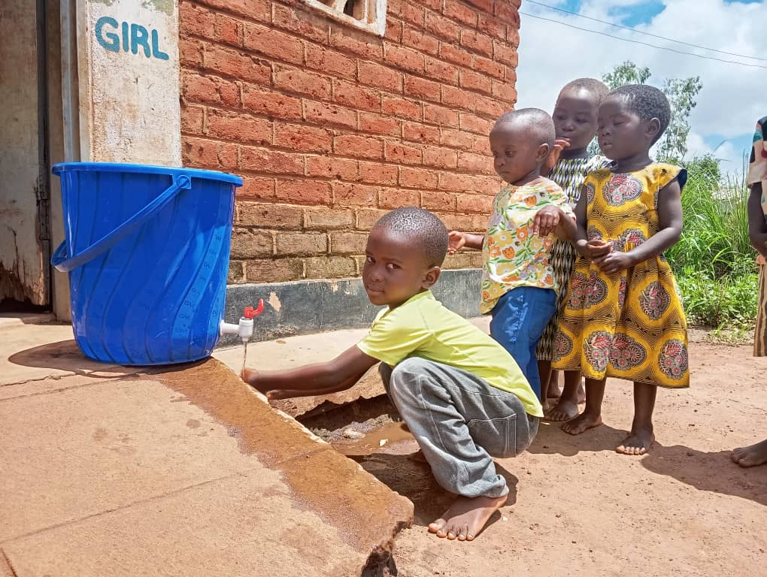
Time to practise proper handwashing: The children practising one after another

Key Focus Areas of the Training/Orientation
- Hand Hygiene: Emphasizing on proper handwashing techniques, frequency, and its importance.
- Infection Control: Empowering the women to Teaching children how to cover their mouths when coughing, dispose of tissues properly, and avoid touching their eyes, noise, and mouths.
- Personal Hygiene: Encouraging child regular bathing, wearing clean clothes, and maintaining oral hygiene.
- Environmental Hygiene: Promote cleaning and disinfecting surfaces, toys, and all other materials regularly.
- Food Safety: Teach the women proper food handling, preparation, and storage practices.

Impact/Benefits of the Health and Hygiene Training/Orientation
- Number of participants: Twenty (20) women representing both CBCCs (of Tiyamike and Mwayiwathu) participated in the training. This indicates that the women were/are so committed to providing health care services to the children in the CBCCs.
- Reduced absenteeism at both CBCCs: Improved hand hygiene practices will very likely lead to low absenteeism rate of the children in the centres.
- Improved health: Proper hygiene habits will very likely reduce the spread of infectious diseases among the children.
- Increased knowledge: Once the women/mothers who have been trained pass on the health and hygiene messages to the children, they (the children themselves) will gain essential knowledge about germ transmission and prevention.
- Better academic performance: Reduced absenteeism and improved health will definitely contribute to better academic outcomes.

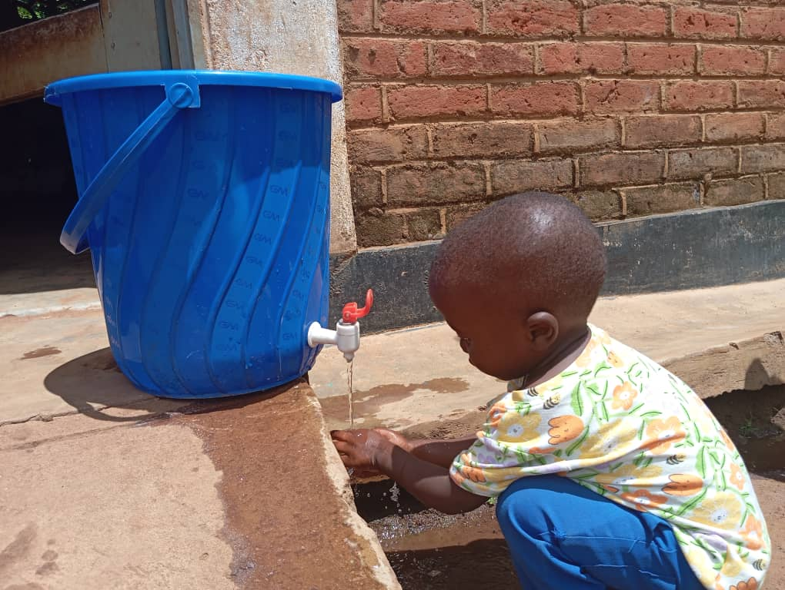
“Now it’s my turn”, This child seems to be saying so while doing the handwashing before his peers

CHALLENGES
- Both trainings, the Business Management and Financial Literacy Training and the Health and Hygiene Training had limited duration to cover all topics for each course.
- Inadequate resources for the trainings.

RECOMMENDATIONS
- The Business Management and Financial Literacy training normally requires a minimum of ten days and at least three day for the Health and Hygiene training, for all the stuff to be tackled/covered. So, in this case there is need for further trainings, probably twice a year until the women are well equipped for their business endeavours.
- On inadequate resources, there is need to consider increasing the resources so they can reach out to all the required areas.

CONCLUSION
Both trainings have so undoubtedly achieved their intended objectives and the impact of each of the trainings is quite great as seen in the report. The participants were very grateful to the UVGI (USA) for the support provided towards these important trainings. Even in her speech, Village Headwoman Ntima (the host of the trainings) assured us (the organizers) that she would make sure that this cordial relationship between her subjects and the UVGI continues to grow from strength to strength for the betterment of her people.

And as UVGI (Malawi) team, we are highly thankful to the Board of Directors and the entire UVGI Management in the USA for all the support towards, not only these trainings, but all other interventions we are implementing in Zomba rural, specifically in Traditional Authority Nkagula. We hope the impact will certainly be that the lives of the target beneficiaries and the entire Nkagula community change completely both in the short-term and in the long-term. On expenditure, we are very proud to report that we spent US$104 for the Business Management and Financial Literacy Training, and US$48 for the Health and Hygiene Training as budgeted, giving a total of US$152. Thanks.

END OF REPORT

